Digital Communication System
A digital communication system transmits information as a sequence of digital signals, typically consisting of 0s and 1s, over a communication channel. This allows for clearer and more reliable transmission compared to analog communication systems, which are susceptible to noise and interference.
Block Diagram:
Information Source -> Source Encoder -> Channel Encoder -> Modulator -> Channel -> Demodulator -> Channel Decoder -> Source Decoder -> Destination
Explanation of Components:
Information Source: This represents the origin of the data you want to transmit. It could be a computer file, a microphone converting sound to electrical signals, a video camera, or any other device that generates digital or analog information.
Source Encoder: If the information source is analog (like a microphone), the source encoder converts it into a digital format, typically a binary stream of 0s and 1s. This may involve techniques like sampling and quantization. Even if the information is already digital, the source encoder may perform tasks like data compression to reduce the amount of data transmitted.
Channel Encoder: The channel encoder adds redundancy to the data stream. This helps in detecting and correcting errors that may occur during transmission due to noise or interference. Common channel coding techniques include error-detecting codes and error-correcting codes.
Modulator: The modulator converts the digital signal from the channel encoder into a signal suitable for transmission over the communication channel. This is because the channel (e.g., a cable, wireless network) may not be able to handle raw digital signals efficiently. Modulation techniques involve varying characteristics (amplitude, frequency, phase) of a carrier signal to represent the digital data.
Channel: This is the physical medium through which the modulated signal is transmitted. Examples include coaxial cables, fiber optic cables, and wireless channels.
Demodulator: At the receiving end, the demodulator recovers the original digital signal from the received modulated signal. It performs the inverse operation of the modulator, deconstructing the variations in the carrier signal to retrieve the encoded data.
Channel Decoder: The channel decoder uses the added redundancy from the channel encoder to detect and correct any errors that might have occurred during transmission.
Source Decoder: If the source encoder performed any data compression, the source decoder reverses the process to recreate the original information. For analog sources, the source decoder may convert the digital signal back into an analog format (e.g., sound or video) suitable for the destination device.
Destination: This represents the receiving end of the communication system, where the information is delivered in its intended form (e.g., displayed on a screen, played as sound, etc.).

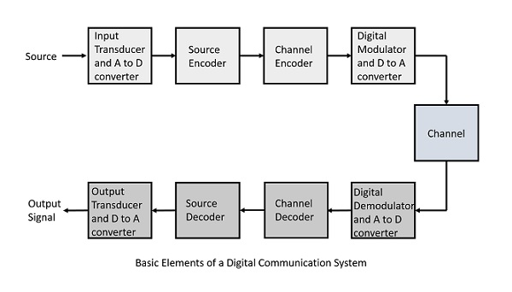
Benefits of Digital Communication Systems:
Reduced noise and interference: Digital signals are less susceptible to noise and interference compared to analog signals.
Error detection and correction: Channel coding allows for detecting and correcting errors that may occur during transmission.
Data security: Encryption techniques can be applied to digital communication systems to ensure data confidentiality.
Efficient transmission: Digital signals can be compressed efficiently for transmission over limited bandwidth channels.

ADVANTAGES OF DIGITAL COMMUNICATION SYSTEM OVER ANALOG COMMUNICTATION SYSTEM
Digital communication has significantly transformed the way we interact, and it offers several benefits compared to traditional analog methods. Here are some key advantages:
Instant Communication:
Digital communication excels in speed. Messages and information can be transmitted instantly, making communication much faster and more efficient.Examples of digital communication include emails, instant messaging, video conferencing, social media platforms, and other online communication tools1.
Cost-Effectiveness:Digital communication is often more cost-effective than traditional methods. It eliminates the need for paper, stamps, and other physical materials.By reducing physical resources, it contributes to cost savings and environmental sustainability.
Accessibility:
Digital communication allows people with disabilities to communicate more easily. Various assistive technologies are available to help them access digital platforms.This inclusivity ensures that everyone can participate in communication regardless of physical limitations.
Convenience:
Digital communication can be accessed from anywhere and at any time, as long as there is internet connectivity or a digital device.Its convenience enhances flexibility and productivity.
Improved Customer Service:
Businesses benefit from digital communication platforms such as social media and email. These tools enable faster and more convenient customer service.Companies can promptly address customer inquiries, complaints, and feedback.
Better Data Tracking:
Digital communication platforms often provide data tracking and analytics tools.Businesses can monitor the effectiveness of their communication efforts, make data-driven decisions, and optimize their strategies.
Enhanced Networking:
Digital platforms facilitate networking and professional relationship-building.Individuals can connect with others in their industry or field, fostering collaboration and knowledge exchange.
Rich Media Sharing:
Digital communication allows for the sharing of rich media such as images, videos, and audio files.This makes communication more engaging, interactive, and expressive.
Technical advantages of digital systems over analog systems:
Better Quality:Digital communication typically provides better quality and clarity than analog communication.Digital signals transmit data without loss or distortion, resulting in improved audio, video, and data transmission.
Flexibility and Adaptability:Digital systems are more flexible. They can be easily modified and adapted to changing circumstances.
In contrast, analog systems are limited by their hardware and design, making them less adaptable.In summary, digital communication offers speed, cost-effectiveness, accessibility, and rich media capabilities, while digital systems provide better quality and greater flexibility compared to analog counterparts

Define and explain bit rate, Baud Rate, information capacity, bandwidth, Nyquist Frequency, Bandwidth efficiency.
Bit Rate: This refers to the number of bits (0s and 1s) that are transmitted per second. It essentially tells you how fast information is flowing through a channel, measured in bits per second (bps).
Baud Rate: This deals with the number of signal events that occur per second. A signal event is a change in the signal state. It doesn't directly tell you how many bits are being transmitted because each signal event might represent multiple bits depending on the modulation technique used. Baud rate is measured in Baud (Bd).
Here's the key difference: Bit rate focuses on the actual information being sent, while Baud rate focuses on the physical changes in the signal.
Information Capacity: This is the maximum amount of data that can be reliably transmitted through a communication channel in a given amount of time, typically measured in bits per second (bps). It's like the maximum speed limit on a data highway.
Bandwidth: This refers to the range of frequencies that a communication channel can carry. It's measured in Hertz (Hz) and indicates the width of the "lane" on the data highway. There's a limited amount of space for signals on a channel, and bandwidth defines that limitation.
Nyquist Frequency: Named after Harry Nyquist, this is the theoretical maximum rate at which data can be transmitted over a channel with a given bandwidth without introducing intersymbol interference (ISI). ISI is a distortion that occurs when closely spaced symbols interfere with each other. The Nyquist frequency is equal to twice the bandwidth (in Hz).
Bandwidth Efficiency: This is a measure of how effectively a communication system utilizes the available bandwidth to transmit data. It's expressed in bits per second per Hertz (bps/Hz). A system with higher bandwidth efficiency can transmit more data using the same amount of bandwidth.
In simpler terms, imagine a pipe carrying water. The bit rate is the amount of water flowing through the pipe each second. The Baud rate is the number of times the water flow changes direction (from low to high pressure or vice versa). The information capacity is the maximum amount of water the pipe can handle without overflowing. Bandwidth is the diameter of the pipe, limiting the total water flow. The Nyquist frequency is like the recommended flow rate to avoid splashing (ISI). Finally, bandwidth efficiency is how well you utilize the pipe diameter to carry water (data).

CHAPTER -2
Digital Modulation:
Digital modulation is the magic trick that allows us to transmit digital information (like 0s and 1s) over analog channels (like radio waves or phone lines). It works by taking a carrier signal, which is a high-frequency analog wave, and varying its properties (amplitude, frequency, or phase) based on the digital data we want to send.
Here's a breakdown of the process:
Digital Input: We have our information in digital form, a series of 0s and 1s.
Carrier Signal: Imagine a high-frequency wave, like a radio wave. This is our carrier signal, and it's the "highway" that will carry our data.
Modulation: We use the digital data to modulate (vary) the carrier signal. There are different modulation techniques that vary different aspects of the carrier wave:
Amplitude Shift Keying (ASK): Here, the amplitude (strength) of the carrier signal is changed based on the data (high amplitude for 1, low amplitude for 0).
Frequency Shift Keying (FSK): In this technique, the frequency of the carrier signal is shifted based on the data (higher frequency for 1, lower frequency for 0).
Phase Shift Keying (PSK): Here, the phase of the carrier signal is shifted to represent the data (specific phase shifts for 1 and 0).
Transmission: The modulated carrier signal, now containing the digital information, is transmitted over the channel (radio waves, phone lines, etc.).
Demodulation: At the receiving end, the modulated signal is demodulated to recover the original digital data. This involves separating the data from the carrier signal.
Digital modulation offers several advantages over analog modulation for transmitting digital information:
Noise Immunity: Digital signals are less susceptible to noise interference compared to analog signals. This is because the receiver can differentiate between intended data variations and random noise.
Data Security: Encryption can be applied to the digital data before modulation, making it more secure during transmission.
Efficiency: Digital modulation techniques can be more bandwidth efficient compared to analog modulation, allowing for more data transmission within a limited bandwidth.
Overall, digital modulation is a fundamental technology that underpins our modern communication systems, enabling the transmission of digital data like voice calls, internet data, and video streams over various channels.

Block diagram description of a basic data communication model and its components consisting of transmitter ,receiver, medium ,message and protocol.

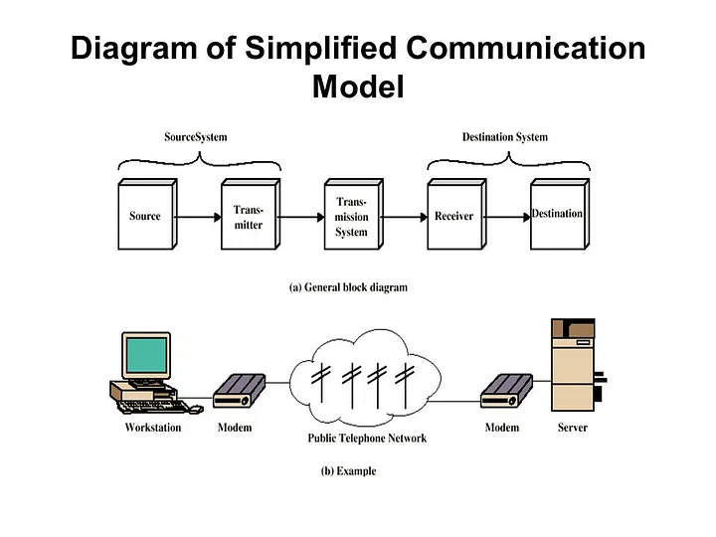
Blocks:

Message Source: This block represents the origin of the information to be communicated. (e.g., computer, phone)
Transmitter: This block processes the message for transmission. (e.g., formatting, error correction, modulation)
Channel (Medium): This represents the physical path through which the data travels. (e.g., cables, radio waves)
Receiver: This block receives the transmitted signal and recovers the message. (e.g., demodulation, error correction, decoding)
Destination: This is the final recipient of the information. (e.g., another computer, speaker)
Protocol: (Not shown in the diagram) This acts as a set of rules governing communication. (e.g., data format, synchronization, error handling)
Data Flow:
Message originates at the Message Source.
The Transmitter processes the message.
The modulated signal is transmitted over the Channel (Medium).
The Receiver demodulates the signal and recovers the message.
The recovered message is delivered to the Destination.
The communication follows the rules of the agreed-upon Protocol.
Modes of Communication:
Simplex Mode: In simplex mode, data flows in one direction only. The sender can transmit data, but it cannot receive data on the same channel. Examples include traditional monitors and keyboards.
Half Duplex Mode: In half-duplex mode, data can be transmitted both ways, but not simultaneously. For instance, walkie-talkies allow messages to be sent one at a time in both directions.
Full Duplex Mode: Full-duplex mode enables simultaneous two-way communication. Senders can both transmit data and receive data simultaneously. Telephone networks operate in full-duplex mode.
Transmission Modes:
Parallel Communication: In parallel communication, multiple bits are transmitted simultaneously using separate channels or wires. It’s commonly used within computer systems for faster data transfer.
Serial Communication: Serial communication transmits data sequentially, bit by bit, over a single channel. It’s often used for long-distance communication.
Asynchronous Communication: In asynchronous communication, data is transmitted in variable-length packets with start and stop bits. It’s commonly used in serial communication.
Synchronous Communication: Synchronous communication maintains a continuous stream of data without start and stop bits. It’s efficient for high-speed data transfer.
Isochronous Communication: Isochronous communication ensures a constant data rate, critical for real-time applications like audio and video streaming.
Guided Transmission Media:
Twisted Pair Cable: Twisted pair cables consist of two separately insulated conductor wires wound around each other. They are commonly used for telephone connections and LAN networks. There are two types:
Unshielded Twisted Pair (UTP): Economical, easy to install, and suitable for short distances. However, it is susceptible to external interference.
Shielded Twisted Pair (STP): Offers better performance at higher data rates, eliminates crosstalk, but is more challenging to install and more expensive1.
Coaxial Cable: Coaxial cables have an outer plastic covering with an insulation layer (PVC or Teflon) and two parallel conductors, each with a separate insulated protection cover. They are used for cable TV networks and analog television networks1.
Fiber-Optic Cable: Fiber-optic cables use light signals to transmit data. They are commonly used in backbone networks, cable TV networks, and Fast Ethernet networks. Fiber-optic cables provide high bandwidth and better noise immunity2.
Unguided Transmission Media:
Radio Waves: Radio waves are used for wireless communication. They propagate through the air and are commonly used for radio broadcasting and Wi-Fi.
Microwaves: Microwaves are used for point-to-point communication, such as microwave towers for long-distance transmission.
Infrared: Infrared waves are used for short-range communication, like TV remote controls.
Satellite: Satellite communication uses geostationary satellites to relay signals across large distances1.
Line-of-Sight Transmission:
Point-to-Point: In point-to-point transmission, signals travel directly between two specific points without any intermediate devices.
Broadcast: Broadcast transmission sends signals from one point to multiple receivers, covering a wider area. Examples include TV and radio broadcasting.
Redundancy Checking:
Vertical Redundancy Check (VRC): In VRC, a parity bit is added to each character (usually at the end) to make the total number of 1s either even or odd. If the received data has an incorrect parity, an error is detected.
Checksum: Checksums involve adding all the data bits together and transmitting the sum. The receiver recalculates the sum and compares it with the received value. If they don’t match, an error is detected.
Longitudinal Redundancy Check (LRC): LRC computes the parity for each column of data bits. If any column’s parity doesn’t match, an error is detected.
Cyclic Redundancy Check (CRC): CRC uses polynomial division to generate a checksum. The sender and receiver both use the same polynomial to verify data integrity. It’s widely used in network protocols like Ethernet.
Error Detection Using Parity:
Even Parity: In even parity, an extra bit (the parity bit) is added to each byte or character. The total number of 1s (including the parity bit) should be even. If not, an error is detected.
Odd Parity: Similar to even parity, but the total number of 1s (including the parity bit) should be odd.
The Sampling Theorem and Sampling Frequency in Pulse Code Modulation (PCM)
The Sampling Theorem is a fundamental principle in digital communication, especially for techniques like Pulse Code Modulation (PCM). Here's a breakdown of both concepts:
Sampling Theorem:
The Sampling Theorem states that a continuous-time signal (analog signal) can be perfectly reconstructed from a discrete-time signal (digital samples) if the sampling frequency (fs) is greater than or equal to twice the highest frequency component (fm) present in the analog signal. This minimum sampling frequency is also known as the Nyquist Rate (fn). Mathematically, it can be expressed as:
fs ≥ 2 * fm
Explanation:
Imagine an analog signal like a musical note. This signal can be represented as a wave that continuously changes over time. When we sample this signal, we take snapshots of its value at specific points in time. These snapshots are our digital samples.
The Sampling Theorem guarantees that if we capture these snapshots frequently enough (at a rate exceeding twice the highest frequency in the original signal), we can recreate the original continuous signal from those samples without any loss of information.

Sampling Frequency in PCM:
Pulse Code Modulation (PCM) is a digital communication technique that converts an analog signal into a digital bit stream. It achieves this by following these steps:
Sampling: The analog signal is sampled at a specific rate (fs) according to the Sampling Theorem.
Quantization: Each sample's amplitude is approximated to a discrete level from a set of possible values. This introduces a small amount of quantization error.
Coding: The quantized values are converted into binary code (a series of 0s and 1s).
The sampling frequency (fs) plays a crucial role in PCM. Here's why:
Higher fs: If the sampling frequency is sufficiently high (adhering to the Nyquist Rate), the reconstructed signal will be a very close replica of the original analog signal.
Lower fs: If the sampling frequency is lower than the Nyquist Rate, a phenomenon called aliasing occurs. In aliasing, high-frequency components in the original signal fold back onto lower frequencies, leading to distortion and an inaccurate reconstruction of the original signal.
Therefore, choosing the correct sampling frequency is essential for accurate and efficient digital representation of analog signals using PCM.
Basic concepts of time division multiplexing (TDM) and frequency division multiplexing (FDM).
Both TDM (Time Division Multiplexing) and FDM (Frequency Division Multiplexing) are techniques for transmitting multiple signals over a single communication channel. Here's a breakdown of their basic concepts:

Time Division Multiplexing (TDM):
Imagine a highway with one lane. TDM works by sharing that single lane with multiple cars (signals) in a time-based manner. Here's how it works:
Dividing Time: The total transmission time is divided into short time slots.
Assigning Slots: Each signal is allocated specific time slots within the overall frame.
Transmission in Bursts: Each signal transmits its data only during its assigned time slot.
Synchronization: A synchronization pulse is crucial to ensure all transmitters and receivers are aligned on the time slots.
Key Points about TDM:

Suitable for: Works well with both analog and digital signals.
Efficiency: TDM can be efficient if the allocated time slots closely match the data rates of the signals. Unused slots lead to wasted bandwidth.
Complexity: TDM circuitry is relatively simpler compared to FDM.
Synchronization: Maintaining synchronization between transmitters and receivers is critical for TDM to function properly.
Frequency Division Multiplexing (FDM):

Imagine a highway with multiple lanes. FDM works by dividing the total available bandwidth of the communication channel into smaller frequency sub-bands. Here's the concept:

Frequency Division: The total bandwidth is divided into non-overlapping frequency bands.
Carrier Signals: Each signal is assigned a unique carrier frequency within a specific sub-band.
Modulation: Each signal modulates its own carrier signal to embed its data.
Filtering: Filters separate the modulated signals before transmission on the channel.
Demodulation: At the receiving end, the signals are separated by filters and then demodulated to recover the original data.
Key Points about FDM:

Suitable for: Primarily used for analog signals. Digital signals can be used with FDM after conversion to analog using techniques like carrier modulation.
Efficiency: FDM might not be very efficient if the bandwidth requirements of the signals don't perfectly fit the allocated sub-bands. Wastage can occur at the edges of the bands.
Complexity: FDM circuitry can be more complex than TDM due to the requirement for filters and modulators/demodulators.
Synchronization: Synchronization is not essential for FDM as signals are separated by frequency.
In essence:

TDM shares a single channel by dividing time, while FDM divides the available frequency range.
TDM can handle both analog and digital signals, while FDM is primarily for analog signals.
TDM is simpler but requires synchronization, whereas FDM is more complex but doesn't require synchronization.

